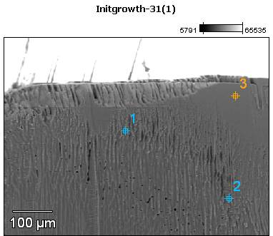

Image Name: Initgrowth-31(1)

Image Resolution: 512 by 384

Image Pixel Size: 1.30 µm

Acc. Voltage: 12.0 kV

Magnification: 190

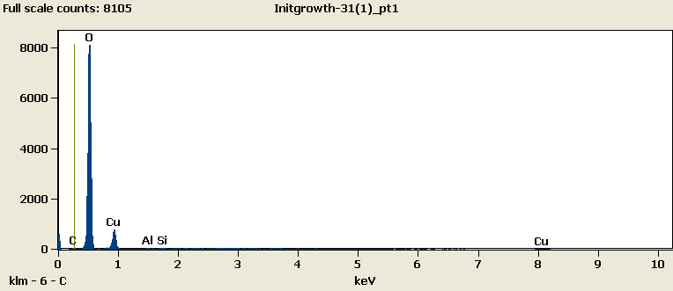

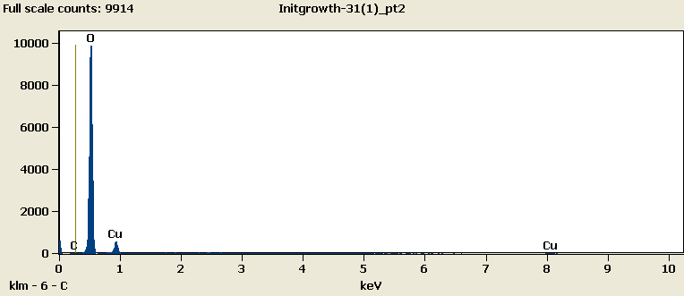

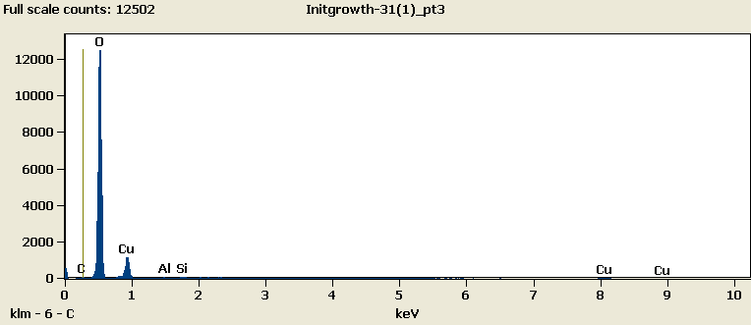

Weight %

|  |  |  |  |  |  |
| --- | --- | --- | --- | --- | --- |
|  | ***C-K*** | ***O-K*** | ***Al-K*** | ***Si-K*** | ***Cu-L*** |
| ***Initgrowth-31(1)_pt1*** | 0.62 | 72.40 | 0.37 | 0.36 | 26.25 |
| ***Initgrowth-31(1)_pt2*** | 0.00 | 79.21 |  |  | 20.79 |
| ***Initgrowth-31(1)_pt3*** | 0.48 | 71.84 | 0.14 | 0.29 | 27.25 |

Weight % Error (+/- 1 Sigma)

|  |  |  |  |  |  |
| --- | --- | --- | --- | --- | --- |
|  | ***C-K*** | ***O-K*** | ***Al-K*** | ***Si-K*** | ***Cu-L*** |
| ***Initgrowth-31(1)_pt1*** | ±0.15 | ±0.33 | ±0.05 | ±0.05 | ±0.42 |
| ***Initgrowth-31(1)_pt2*** | ±0.00 | ±0.33 |  |  | ±0.40 |
| ***Initgrowth-31(1)_pt3*** | ±0.12 | ±0.29 | ±0.04 | ±0.04 | ±0.35 |

# Cations

|  |  |  |  |  |  |
| --- | --- | --- | --- | --- | --- |
|  | ***C-K*** | ***O-K*** | ***Al-K*** | ***Si-K*** | ***Cu-L*** |
| ***Initgrowth-31(1)_pt1*** | 0.00 | 0.00 | 0.00 | 0.00 | 0.00 |
| ***Initgrowth-31(1)_pt2*** | 0.00 | 0.00 |  |  | 0.00 |
| ***Initgrowth-31(1)_pt3*** | 0.00 | 0.00 | 0.00 | 0.00 | 0.00 |